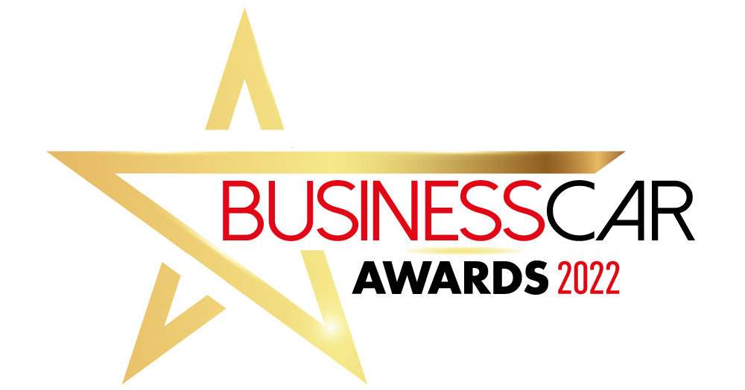

Best Customer Service

Name:

Email:

Company name:

Job title:

Telephone:

Company entering award:

Award accepter and job title:

What strategies have you put in place to promote ‘customer service’ in your company.

How has this strategy worked, what evidence can you provide to support?

In summary, tell us why you think you should win this award.

